American Sign Language detection using machine learning algorithms

Shanmukhanand G

Spring 2020

More Analysis

Did more analysis on the data to understand how the data is distributed. Used the reference of the famous model for image detection and object detection: “hand written digit identifier”. Some of the images of sign language were very similar to others and some were not recognizable.

Model fitting

For the model fitting, I have used label binarizer to encode the categorical values of label parameter. I had to normalize the data values. My data values ranged from 0 to 255 so I have divided my image values by 255

Images of sign D

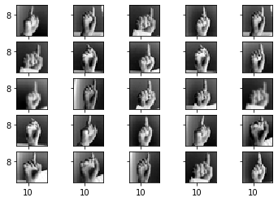

I did some preprocessing of data by using keras preprocessing library. The preprocessing helped me achieve more accuracy and hence was a great input to the model.

Accuracy

I was able to achieve an overall accuracy of 96% with a little bit of noise. I had random fluctuations of accuracy at epochs 26-32. After 40 epochs the test data showed a constant accuracy of 1.00

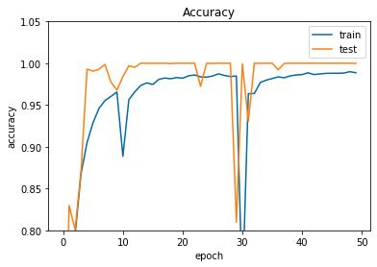

Things to do

I still have to find some new model to increase the accuracy and also build a real time ASL detection model. Try to build a model to detect letter ‘Z’ as it has motion involved. Also build a model to detect sign in videos.

Reference

1. *Tzanakou, E.M., 2000. Classifiers: An Overview,from Supervised and Unsupervised Pattern Recognition: Feature Extraction and Computational Intelligence. CRC Press LLC.,ISBN: 0-8493-2278-2, pp: 371.*
2. *Sebastian Raschka. 2015. Python Machine Learning. Packt Publishing.*ISBN**:** 978-1-78355-513-0
3. Dataset: <https://github.com/blackbird71SR/Neural-Network-Projects/tree/master/Sign%20Language%20and%20Static-Gesture%20Recognition/dataset>